### Diabetes Mellitus Prediction Using IBM Auto AI Service

Project Report

INDEX

1 INTRODUCTION

1.1 Overview

1.2 Purpose

2 LITERATURE SURVEY

2.1 Existing problem

2.2 Proposed solution

3 THEORITICAL ANALYSIS

3.1 Block diagram

3.2 Hardware / Software designing

2 EXPERIMENTAL INVESTIGATIONS

3 FLOWCHART

4 RESULT

5 ADVANTAGES & DISADVANTAGES

6 CONCLUSION

7 BIBILOGRAPHY

APPENDIX

1. Source code

**INTRODUCTION**

**1.1 Overview**

Diabetes mellitus is a chronic disease characterized by hyperglycemia. It may cause many complications. According to the growing morbidity in recent years, in 2040, the world’s diabetic patients will reach 642 million, which means that one of the ten adults in the future is suffering from diabetes. In this project, i build a machine learning model that can efficiently discover the rules to predict diabetes mellitus of patients based on the given parameter about their health. This model was deployed in the IBM cloud to get scoring endpoint which can be used as API in web app building. . The model prediction was showcased on User Interface.

**1.2 Purpose**

Experience all the essential steps by building the Cognitive Application based on Data Science (AI, Machine learning) Build, Train, and analysis the Model in Watson Studio Deploy and expose the model in Watson Machine Learning Build up the Cognitive Application based on the deployed Model. The Data with well known features which could be used by a common understandable applications. Pima Indians Diabetes Database (Primary Project).

**EXPERIMENTAL INVESTIGATIONS**

In this process of developing the project I have undergone many investigation processes to learn and understand new concepts so that I can build the news search application successfully. For I had to learn and investigate following:

1. IBM Watson Studio
2. IBM Watson Machine Learning
3. Node-RED
4. IBM Cloud Object Storage

**FLOWCHART**

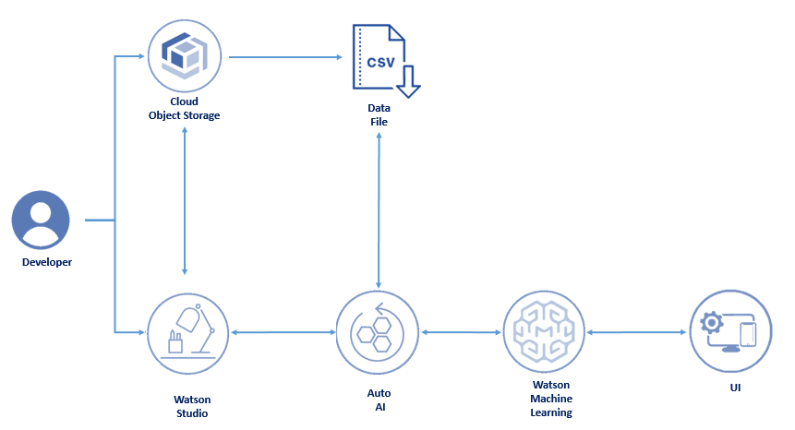

**RESULT**

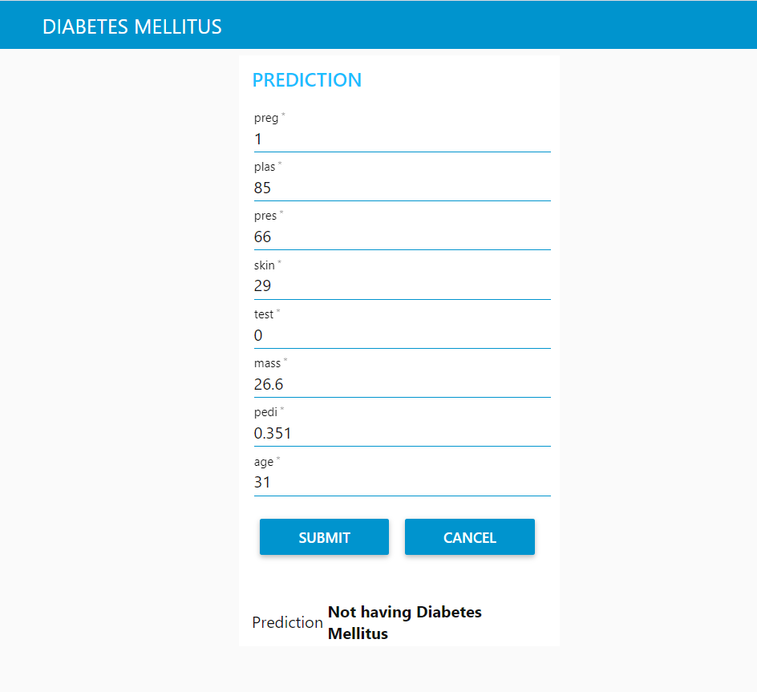

**ADVANTAGES**

The Watson news search application includes following advantages:

* Easy to create.
* Less time required to develop.
* High performance with IBM cloud.

**DISADVANTAGES:**

The Watson news search application includes following disadvantages:

* We need to pay for IBM platform service.
* The services which we use require amount for space we use.

**CONCLUSION**

This project gave you some basic working knowledge of the Watson Discovery Service and shows how to use Discovery along with JavaScript and Node Red to build your own news mining web application. This project also tells about the integration process of Watson services to access.

**BIBILOGRAPHY**

**Names**: Karthik V

**College Name**: Coimbatore Institute of Technology.

**Work Title:** Diabetes Mellitus Prediction Using IBM Auto AI Service.

**References:**

1. IBM Cloud: <https://www.ibm.com/cloud/get-started>
2. Node red tutorial: <https://developer.ibm.com/tutorials/how-to-create-a-node-red-starter-application/>
3. About API:

<https://www.youtube.com/watch?v=s7wmiS2mSXY&feature=youtu.be>

1. Watson services and product: <https://www.ibm.com/watson/products-services>
2. IBM Watson Discovery: <https://developer.ibm.com/articles/introduction-watson-discovery/>

**APPENDIX**

**Link to Node Red work space:**

**Link to Node Red UI:**